Employment & Enrichment

Executive Guest Speaker Series - Snapshot

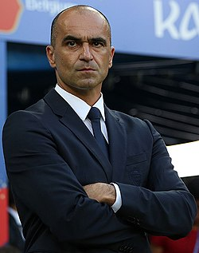  Roberto Martinez Belgium Manager | 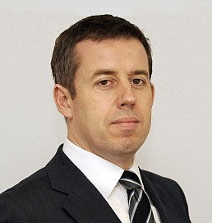  Matt Lawton  Chief Sports Reporter | Malle Koido  Sports Agent | Keeley Baptista  Kick it Out
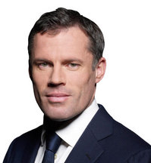  Jamie Carragher  Ex-Pro, Sky Sports Pundit | 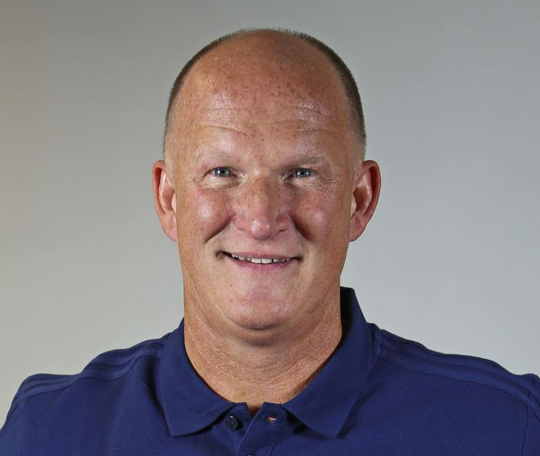  Simon Grayson  Football Manager | Philip Bernie  Head of BBC Sport | 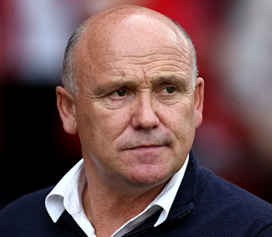  Mike Phelan  Football Manager

Employment & Enrichment courses and sessions – Snapshot

- Neil Doncaster’s Management Games
- Peter Smith’s Match Commentary
- Match Data Analysis
- Languages
- Ian George’s Business Skills and Football Investments
- Employer Showcase Events
- Plus, many more…

Work Placements & Internships – Snapshot
